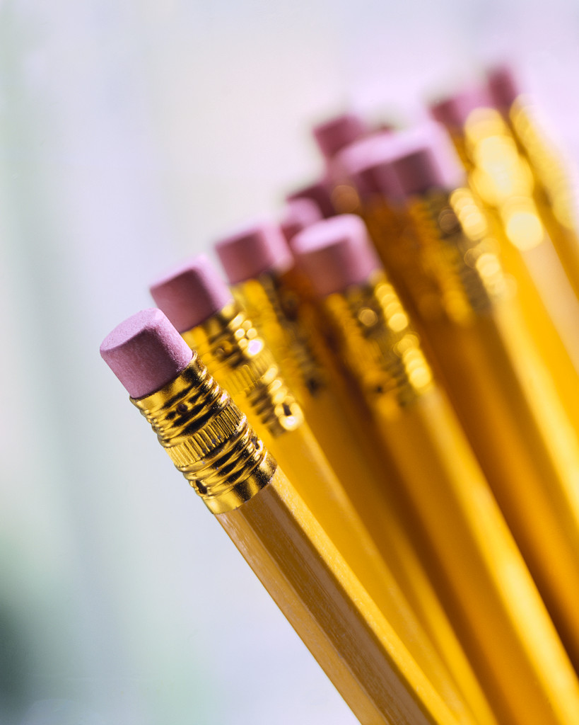
Hopewell Memorial Junior High School
6th Grade Supply List

- One soft zippered pencil pouch
- One highlighter (minimum) – Any color
- Three wooden #2 pencils (no mechanical pencils)
- One box of colored pencils
- Pencil top or wedge eraser
- Two wide ruled, single subject notebooks
- Ear-buds for personal use with computers

