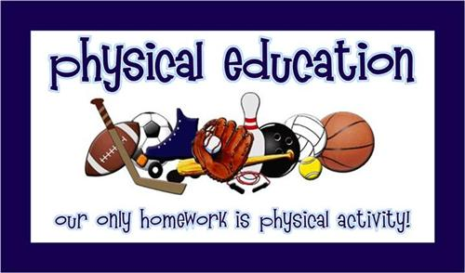

**Physical Education Philosophy**

**In Physical Education, every child deserves a well rounded education that reaches the whole student. This is done by first, educating each student in fitness concepts and skill development which will lead into game strategy, fair play and teamwork. The units of instruction should be age appropriate and reach the physical, mental and social domains of each child. Next we need to motivate each student by meeting them where they are. Find out what ignites their internal drive to build that fire to learn while increasing their confidence and ensuring success at their level. Finally we need to continue to foster this drive by guiding the students to develop an appreciation for physical activity in both sports and fitness. This will allow them to lead an active and healthy lifestyle both now and into adulthood.**